**NOTE: visit** [**https://www.w3schools.com/**](https://www.w3schools.com/) **and learn, for answering questions below.**

1. td stands for Table Data
2. tr stands for Table Row
3. th stands for Table Head
4. <caption> defines Table Caption
5. <thead> is used for Groups the header content in a table
6. <tbody> is used for Groups the body content in a table
7. <tfoot> is used for Groups the footer content in a table
8. Show style to define table borders: it fill the background with color and border is invisible.
9. What does border-collapse does: it collapse the border into a single border.
10. Make an html file roundTable.html and make a table similar to this

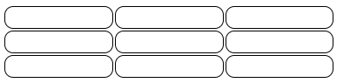

1. Make an HTML file dottedTable.html and make a table similar to this.

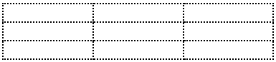

1. Make an HTML file fullwidth.html, it should have a  table with a width of 100%.
2. What does colspan do?

* It specify the number the column a cell should span.

1. What does rowspan do?

* It specify the number the row a cell should span.

1. Make an HTML file multitable.html, it should have the following 4 tables.

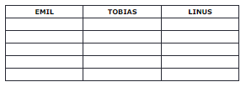

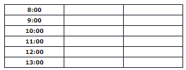

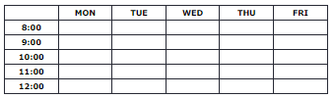

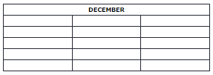

1. What does padding do?

* It create the space around the element content.

1. Make an HTML file zebra.html, and make the following tables with Zebra stripes as follows.

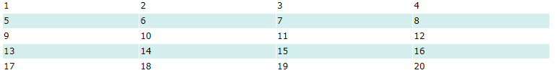

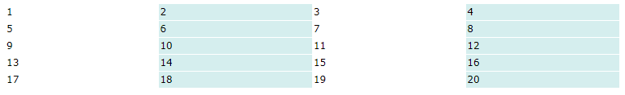

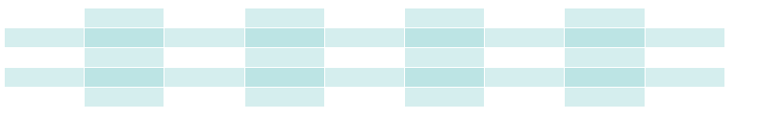

1. Create an HTML file named table.html, and create the following table in it.



**HTML FORMS**

1. What form is used to collect data from the user.
2. Explain following input tags

<input type="text"> It defines a single-line text input field

<input type="radio"> It defines a radio button like select the option.

<input type="checkbox"> It defines a checkbox like to marks the box.

<input type="submit"> It defines a button for submitting form data to a owner.

<input type="button"> It define a button that pop up and show the message.

1. What is <label>  tag? How it is useful for screen readers? What is the use of for attribute in label tag?

* It defines a label for several form elements.
* the screen-reader will read out loud the label when the user focus on the input element.

1. Why name attribute for input is necessary?

* To Specifies the name of the form

1. What are the method and action attributes of the form element?

* Method define the type of fill form to send, and action specific the file that submitted to.

1. What does <select> element do?

* It is used to create a drop-down list.

1. How to allow multiple selections in select elements?

* It specifies that multiple options can be selected at once.

1. What does <textarea> element do? What do rows and cols attributes do?

* It defines a multi-line text input control like 3-5 lines gives for input. Rows specific the number of line of text, and cols specific the width.

1. What do fieldset and legend elements do?

* It is used to group related elements in a form.

1. Create an HTML file contactUs.html and create the following form in it.

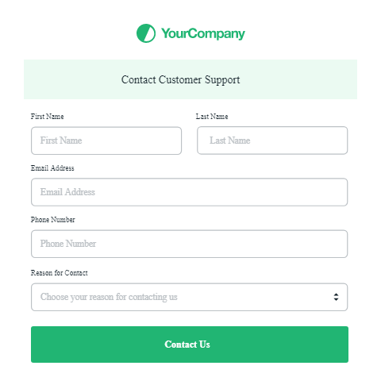

1. Create an HTML file BioData.html and create a form in it to input the following information.

FirstName, LastName, Email address, Phone number, Date of birth, Marital status, Religion, language, Qualification, Address, Place of Birth, years of Experience